SCTP: Stream Control Transport Protocol

Multimedia Systems

Fall 2013 semester project

Rahul Singhal

**Project Goals**

The goal of the project is to implement Stream Control Transport Protocol (SCTP) to transport different type of data on separate channels in a network. Any type of the data can be sent on different channels in the network without head-of-line blocking on each stream. The data on different channels are sent independently without blocking the other channels.

**Design Details**

The project is designed to send any type of multimedia data over the SCTP channels from a server to the client. The server continuously listens for a new client to connect, once the client is connected to the server on the specified port and ip address and server creates the new sctp channels and sends the files over these channels to the client.

The client is explicitly specified what type of files are to be received from the server. The client continuously receives data from the server on different streams and finally combines all the chunks of the files.

**Implementation Platform specification**

The project is currently implemented on Linux platform using c as the programming language. The project requires external support for sctp one such being Linux Kernel Stream Control Transmission Protocol Tools.

The package can be installed using the following command on Linux:

sudo apt-get install libsctp-dev lksctp-tools

For windows support, a 3rd party tool SctpDrv, a sctp driver for windows.

The code can be run on the windows machine with the use of the SctpDrv tool and porting the existing code from linux platform to windows platform.

**Implementation Architecture details**

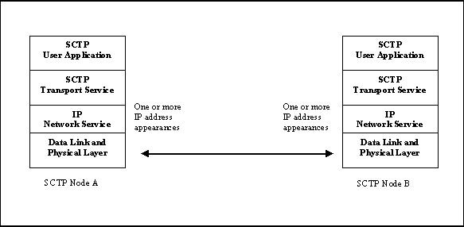

**Performance of your system**

The project is designed to send 1024 bytes of data at once and hence takes a little while to send all the chunks of the files. The size of the sending data can be increased to a point that it does not experience data loss.

**Challenges and Lesson learnt**

SCTP is relatively new concept and has very limited implementation details. There are many papers which describes the features with some experimental results but, very few details about the implementation.

**Project Execution Instructions**

Compile the code using the following commands:

gcc -Wall -g <filename>.c -lsctp -o <filename>

gcc -Wall -O2 <filename>.c -lsctp -o <filename>

It is necessary to link the libraries to the code while compiling and the code can be executed in the following order:

./server

./client

Once executed, the files are sent from the server to the client on different channels.